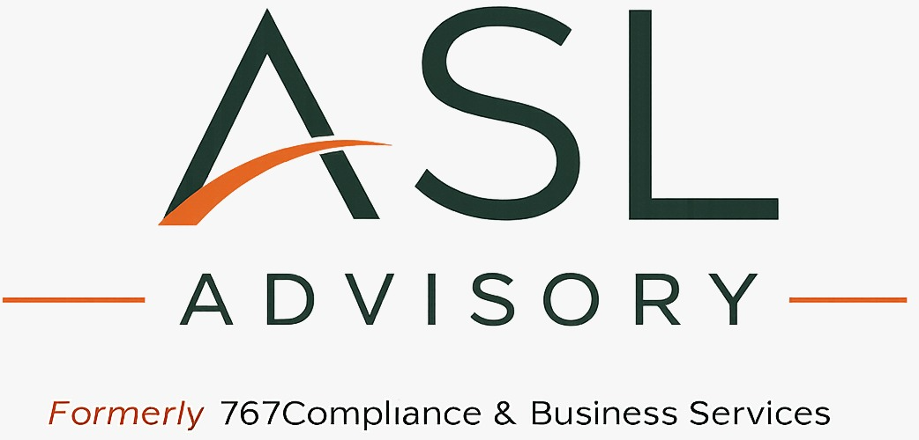

Executive Coaching Programme

Coaching Agreement & Confidentiality Statement
Thank you for choosing to participate in the ASL Advisory Executive Coaching Programme.
Executive coaching is a collaborative partnership designed to support self-awareness, behavioural growth, and intentional leadership development. The coaching process provides a confidential space in which you can reflect, explore challenges, consider new perspectives, and strengthen your effectiveness as a leader.
To ensure a productive and trusting coaching relationship, the following principles will guide our work together.

Confidentiality
Confidentiality is fundamental to the coaching relationship.
All discussions, reflections, personal insights, assessment results, coaching notes, and materials shared during coaching sessions will be treated as confidential and will not be disclosed to any third party without your prior consent, except where disclosure is required:
- by law;
- where there is a risk of serious harm to yourself or another person; or
- where professional or ethical obligations require disclosure.
Where coaching is sponsored by an organisation, the content of coaching conversations will remain confidential. Only information specifically agreed to by the participant will be shared with the sponsoring organisation.

Nature of Coaching
Executive coaching is a professional development process designed to increase self-awareness, strengthen leadership capability, and support behavioural change.
Coaching is not:
- therapy or counselling;
- legal advice;
- financial advice;
- medical or psychological treatment;
- performance management.
Participants remain responsible for their own decisions, actions, and outcomes.

Coaching Partnership
The coaching relationship is built upon mutual trust, openness, respect, and shared responsibility.
As your Executive Coach, I commit to:
- creating a safe, respectful, and confidential environment;
- listening with curiosity and without judgement;
- asking thoughtful questions that encourage reflection and insight;
- supporting your behavioural and leadership development;
- maintaining professional and ethical coaching standards.
As the participant, I ask that you commit to:
- attending sessions as scheduled;
- participating openly and honestly;
- taking responsibility for your own learning and development;
- completing agreed reflections or behavioural experiments between sessions where appropriate;
- communicating openly if coaching needs or expectations change.

Assessments
As part of the coaching programme, assessments such as Extended DISC® may be used to support self-awareness and reflection.
These assessments are intended to facilitate coaching conversations and should not be regarded as measures of intelligence, competence, personality, or leadership potential.

Learning and Continuous Improvement
As part of my commitment to continuous professional development, I regularly reflect on my coaching practice and refine my methodology.
General themes and learning may be incorporated into the ongoing development of the ASL Advisory Executive Coaching Methodology™.
No personal information, identifying details, or confidential client information will ever be included without your explicit written consent.

Agreement
By signing below, we acknowledge that we have read and understood this Coaching Agreement and Confidentiality Statement and agree to participate in the coaching relationship in accordance with the principles outlined above.

Participant
Name: ______________________________________
Signature: _________________________________
Date: ______________________________________

Executive Coach
Annette Severin-Lestrade
Executive Coach
ASL Advisory & Business Services
Signature: _________________________________
Date: ______________________________________

